EXPERIMENT 7
Ex. No.: 7
Impedance Matching with a Short-Circuited Stub
AIM: To study impedance matching of a transmission line using a short-circuited stub with the help of Scilab.
SOFTWARE REQUIRED: Scilab 6.1.1
PROCEDURE: Enter Z0, ZL and the frequency. Calculate the wavelength and the phase constant, then find the normalized load impedance zL = ZL/Z0 and the normalized load admittance yL = 1/zL, which are used on the admittance circle to locate the stub.
PROGRAM
clear; clc;
Z0=50; ZL=100-%i*50; f=1e9; c=3e8;
lambda=c/f; beta=2*%pi/lambda;
zL=ZL/Z0;
yL=1/zL;
printf("Normalized load impedance = %.4f + j%.4f\n",real(zL),imag(zL));
printf("Normalized load admittance = %.4f + j%.4f\n",real(yL),imag(yL));
printf("Wavelength = %.4f m\n",lambda);
printf("Stub matching values are obtained from the admittance circle.\n");
TEST CASES AND OUTPUT
Test Case 1: Z0=50 Ω, ZL=100−j50 Ω, f=1 GHz
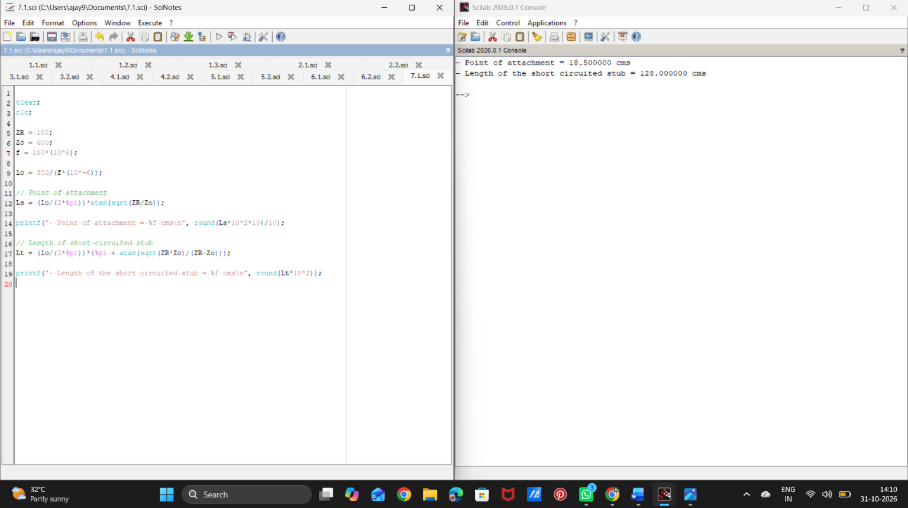

Test Case 2: Z0=50 Ω, ZL=75−j25 Ω, f=1 GHz

RESULT
Thus, the normalized load impedance and admittance required for short-circuited stub matching were computed using Scilab.

